BUILDING AND TESTING FLOYD'S ALGORITHM

By

DANG VAN DONG

Submitted to

The University of Liverpool

MASTER-OF-SCIENCE- DATA SICENTIST AND AI

Practical Assessment: Programming

Word Count: 1355

23/02/2024

BUILDING AND TESTING FLOYD'S ALGORITHM

Submitted to

The University of Liverpool

Word Count: 1355

23/02/2024

TABLE OF CONTENTS

Page

Chapter 1. Introduction And Abstract 2

Chapter 2. Implementation of Floyd's Algorithm 2

Chapter 3. Performance Testing 4

Chapter 4. Unit Testing 4

Chapter 5. An Analysis of Floyd's Algorithm Variations: Recursive vs. Iterative Implementation 4

Chapter 6. Conclusions 5

Reference 6

APPENDICES 7

Introduction And Abstract
Embarking on this academic pursuit, I delve into the realm of algorithmic refinement, particularly focusing on the augmentation of Floyd's algorithm through recursion. Rooted in the principles of Python Enhancement Proposal standards, my report unfolds with the iterative rendition of Floyd's algorithm as delineated in the provided PDF. Guided by the iterative approach, I navigate through the intricacies of algorithmic construction, striving to craft a recursive counterpart. As I traverse the algorithmic landscape, I draw parallels between recursive function calls and the interconnected nodes, illuminating the path towards uncovering optimal solutions.
My report is not confined solely to algorithmic implementation. Recognizing the paramount importance of validation and assessment, I meticulously construct a comprehensive testing framework. Through the deployment of unit tests and performance evaluations, I endeavor to ascertain the correctness and efficiency of the recursive implementation compares with its iterative predecessor.

Implementation of Floyd's Algorithm
The Python script Floyd_Algorithm_Rewrite_Recursion.py (repo link), implements Floyd's algorithm for finding the shortest paths between all pairs of vertices in a graph. The implementation uses a recursive approach with PEP standard. The transition from the imperative solution to the provided application illuminates a journey of algorithmic refinement and implementation. Let delving into the intricacies of the functions in my application:
- NO_PATH = float('inf'):
Initially presented with a distance matrix encapsulating node-to-node distances, I emulate this structure in my application, adhering to Pythonic conventions by employing float('inf') to denote absence of direct paths. As for the choice of NO_PATH = float('inf') over NO_PATH = sys.maxsize, it's essential to emphasize its clarity and consistency. Utilizing float('inf') intuitively represents absence of a direct path by infinity, enhancing readability and comprehension.
- Graph:
Graph is a 2D list representing the distance matrix of the graph that is provided in Imperative Solution. Each inner list corresponds to distances from a specific node to all other nodes. It serves as the foundation for computing the shortest paths between nodes.
graph = [[0, 7, NO_PATH, 8],
[NO_PATH, 0, 5, NO_PATH],
[NO_PATH, NO_PATH, 0, 2],
[NO_PATH, NO_PATH, NO_PATH, 0]]
MAX_LENGTH = len(graph[0])

- MAX_LENGTH = len(graph[0]):

MAX_LENGTH stores the number of nodes in the graph. It is calculated by obtaining the length of the first inner list in the distance matrix, assuming the matrix is square.

- Floyd_recursive(distance, intermediate, start_node, end_node):

- This function computes the shortest path between two nodes within the graph using recursion.
- Parameters:
  - distance: The distance matrix representing the graph.
  - intermediate: The intermediate node being considered in the path.
  - start_node: The starting node of the path.
  - end_node: The destination node of the path.
- Base Case:
- If start_node equals end_node, indicating that the destination has been reached, the function returns 0.
- Recursion:
- The function recursively explores two possibilities:
- A path without considering the current intermediate node (without_intermediate).
- A path that includes the current intermediate node (with_intermediate), split into two recursive calls.

The minimum distance between these two possibilities is chosen and returned.
This function encapsulates the essence of Floyd's algorithm, efficiently exploring all possible paths to determine the shortest one.

- Floyd(distance):

- This function orchestrates the execution of Floyd's algorithm across the entire graph.
- It iterates through all pairs of nodes and computes the shortest path between them using the floyd_recursive function.
- Parameter:
- distance: The distance matrix representing the graph.
- The resulting distances are updated in the distance matrix, refining the graph.

- Execution of Floyd's Algorithm:

- The floyd function is called to compute the shortest paths within the graph.
- After execution, the resulting distance matrix is printed row by row, providing a comprehensive overview of the computed shortest paths with the result as picture 1:

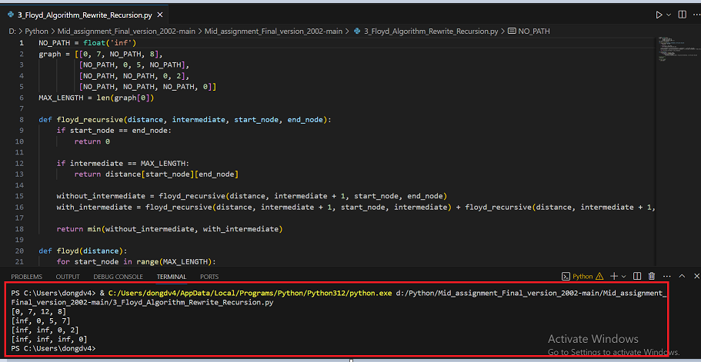
Picture 1: Result of the Floyd Algorithm

Along with my Python script, The Readme.md and Requirement.txt files are crucial for project documentation and management. Readme.md provides an overview of the project, while Requirement.txt lists dependencies. Since the project uses basic Python dictionaries, generated by PipReqs, Requirement.txt remains empty, as no additional dependencies are required to run the code.

Performance Testing
Performance testing is crucial to ensure that the algorithm performs optimally, particularly when dealing with large datasets or complex graphs. By measuring the execution time, potential bottlenecks or inefficiencies can be identified and addressed, ultimately enhancing the algorithm's effectiveness in real-world applications.
The Performance Floyd_Algorithm_Performance_test.py script (repo link) demonstrates the execution time of the Floyd-Warshall algorithm for a larger graph. To ensure the efficiency and performance of the algorithm, a performance test is conducted using the ‘timeit’ module. This module allows precise measurement of execution time for the Floyd-Warshall algorithm. By repeatedly executing the algorithm and measuring the time taken, the performance test provides insights into the efficiency of the implementation.
I opted for the ‘timeit’ module over ‘cProfile’ for its simplicity in measuring the Floyd-Warshall algorithm's execution time precisely. While cProfile is more suitable for profiling entire program performance, ‘timeit’ is ideal for focused, accurate measurement of specific code snippets' execution time.
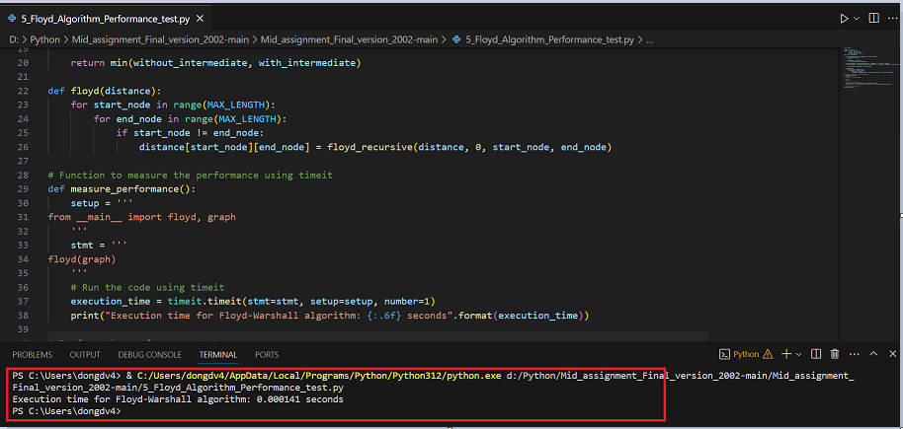
Picture 2: Result of performance testing

Unit Testing
The Floyd_Algorithm_Unit_test.py script (repo link) demonstrates the unit test for each function of the Floyd-Warshall algorithm. The unit test code, utilizing Python's ‘unittest’ module.
The ‘unittest’ module is utilized for this purpose, defining test cases to validate the floyd function's behavior against expected results. The TestFloyd class contains a test method, test_floyd_algorithm, which asserts that the computed shortest paths match the expected results for a given input graph.
By writing unit tests, we ensure that the Floyd-Warshall algorithm functions as expected, providing confidence in its correctness and reliability. Unit tests also facilitate the identification of any regressions or unexpected behavior that may occur during code modifications or refactoring, thereby supporting the maintenance and evolution of the algorithm over time.
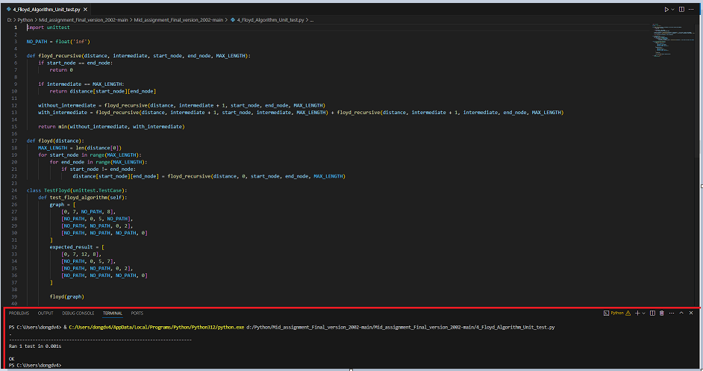
Picture 3: Result of Unit testing

An Analysis of Floyd's Algorithm Variations: Recursive vs. Iterative Implementation
This chapter explores the construction of two versions of Floyd's algorithm for finding the shortest paths in a weighted graph. The first version utilizes a recursive approach, while the second employs an iterative method. The report investigates the development process, and the performance differences between the two implementations.
The iterative version, as illustrated in the PDF, uses a simple iterative loop to update the distance matrix. The loop iterates through all possible combinations of intermediate, start, and end nodes. Similar to the recursive version, the algorithm assumes that if the start and end nodes are the same, the distance is zero. The iterative version has a more straightforward structure compared to the recursive one as mentioned in chapter 2.
The performance variance between iterative and recursive implementations stems from the additional overhead inherent in recursive function calls. Recursion incurs increased function call overhead and may necessitate a larger number of recursive calls, impacting overall execution time. Iterative solutions typically entail fewer function invocations and maintain a constant stack size, potentially resulting in faster execution. Moreover, iterative approaches often benefit from optimized loop structures provided by compilers and interpreters. However, the choice between recursion and iteration depends on factors like problem complexity, language support for optimization, and developer preference, with recursion favored for clarity and simplicity in some contexts despite its overhead.

Conclusions
In reflecting on this academic journey of refining Floyd's algorithm, transitioning from its iterative to recursive implementation has been an illuminating exploration. Rooted in Python Enhancement Proposal standards, the recursive approach unveils the algorithm's intricacies, shedding light on its recursive nature. Opting for NO_PATH = float('inf') over NO_PATH = sys.maxsize offers a clearer and more consistent representation, enhancing readability. Moreover, the meticulous construction of a testing framework, including unit tests and performance evaluations, ensures the correctness and efficiency of the implementation. Through performance testing with the 'timeit' module and 'unitest', the algorithm's reliability and robustness are affirmed, supporting its maintenance and evolution over time. The comparative analysis between recursive and iterative implementations underscores the trade-offs between simplicity and performance, emphasizing the importance of selecting the appropriate approach based on problem complexity and personal preference. Overall, this journey sheds light on the intricate nuances of algorithmic design and optimization, paving the way for further advancements in the field.

Reference

- Github link: https://github.com/Dangmelvin/Mid_assignment_Final_version_2002/tree/main
- shanikawick (2023), Recursion vs. Iteration: Choosing the Right Approach in Ext JS. Available at: https://www.sencha.com/blog/recursion-vs-iteration-choosing-the-right-approach-in-ext-js/. Accessed at: 20 Feb 2024.
- Interviewkickstart, Difference Between Recursion and Iteration. Available at: https://www.interviewkickstart.com/learn/difference-between-recursion-and-iteration. Accessed at: 20 Feb 2024.
- Edward Huan (2021), Is Recursion Really Slower than Iteration?. Available at: https://edward-huang.com/2021/02/17/is-recursion-really-slower-than-iteration/. Accessed at: 20 Feb 2024

APPENDICES

